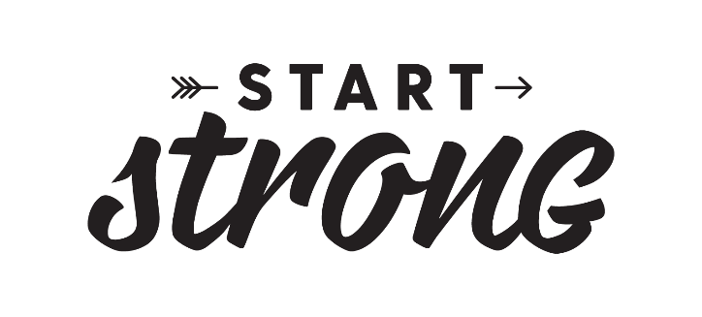
Start Strong with Breakfast
Program Participation Form
Please complete form and email to
Brianne@wadairy.org or mail to
Start Strong with Breakfast Program
4201 198th St. SW Lynnwood, WA 98036
Schools will be selected on a first come first serve basis.

The Start Strong with Breakfast Program is designed to be used as a district-wide, multiple school promotion. First priority will be given to districts with multiple participating schools.
District information:
School District:
School Nutrition Director (SND):
Start Strong with Breakfast Program Manager (if not SND):
Shipping Address:
City:
State:
Zip:
Phone:

Email:
- Which brand of milk do you use?

- Which brand of yogurt do you use?

- Which new menu item do you plan to serve: Hot Chocolate milk or a Fruit and Yogurt Smoothie?

- Planned launch date:
Month:
Day:
Year:

- Please indicate the days of the week you plan to offer the new breakfast menu item.
(Place an “X” in the boxes below.)

Monday | Tuesday | Wednesday | Thursday | Friday | Everyday
- Participating School(s) Information: Please complete the chart(s) below for the participating school(s) which will launch the new menu item. Please give the name of each school, school enrollment, and the average daily participation for the last full month of service.
(Please add rows as needed)
Elementary School Name | School Enrollment | Breakfast ADP | Lunch ADP
(Please add rows as needed)
Middle School Name | School Enrollment | Breakfast ADP | Lunch ADP
(Please add rows as needed)
High School Name | School Enrollment | Breakfast ADP | Lunch ADP
(Please add rows as needed)
- Please attach a copy of your current menu or enter the web address where it is posted.

- Are you interested in applying for the equipment rebate*? (if Yes, a Start Strong Equipment Rebate Application will need to be completed)

Districts may apply for rebates for multiple schools to launch the new menu item. Ninety percent of equipment total used to launch the new menu item may be rebated according to the table below:
Student Enrollment | Rebate Value (90% of total)
1 school with <500 students | Up to $250.00
1 school with >500 students | Up to $500.00
Cap | Max of up to $5,000.00
*In order to receive any equipment rebate funds, the Start Strong Equipment Rebate Application must be received and accepted, and a copy of the paid invoice for qualifying items must be submitted to the Washington Dairy Products Commission before December 16, 2019. See Equipment Rebate Application for complete details. Value of the rebate will not exceed cost of equipment applied for/invoiced.

I understand that if selected for the Start Strong with Breakfast promotion, participating schools within my district must complete the following requirements. School districts will be selected to participate on a first come first served basis.
- The signage provided by Washington State Dairy Council will be hung in each of the participating schools.
- The new menu item will be promoted using two methods: PA announcements, teacher announcements and/or parent emails.
- The school data report will be completed 60 days after launch date. (Data report will include: ADP: 1 month prior to participation, launch month, month after launch for each participating school)
- The equipment will be utilized for support of the new menu item (See Start Strong Equipment Rebate Application). Receipts/Invoices from the purchase of equipment will be submitted to the Washington Dairy Products Commission prior to December 16, 2019 for rebate.

School Nutrition Director Signature:
Date:

For WSDC Use only.
Date Received: Accepted Declined

